

Day -2: Easy Programs (6-30)

Name: M. Sahasra
Reg. No.: 192425317
Course Code: CSA0919
Course Name: Programming in Java for Spring Framework
Faculty Name: Dr. Magesh Kumar

6. Count Number of Vowels in a Statement

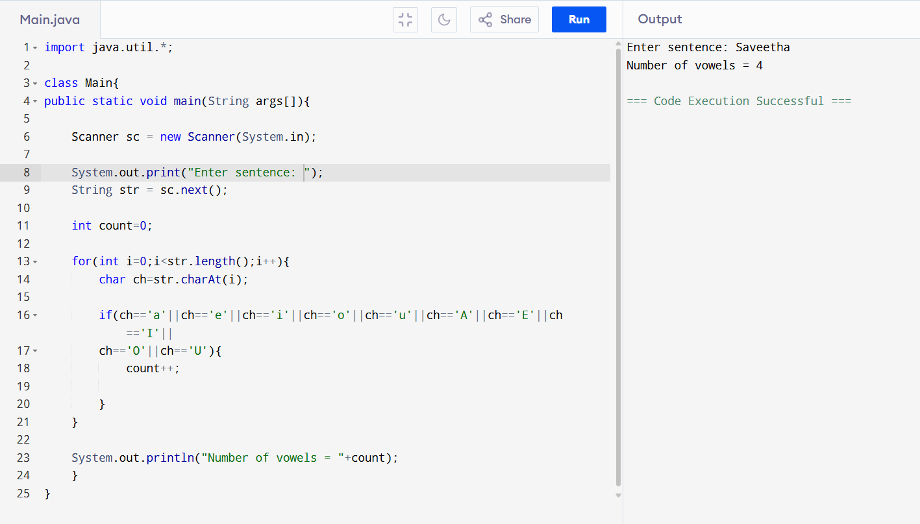

7. Print Vowels and Consonants Separately

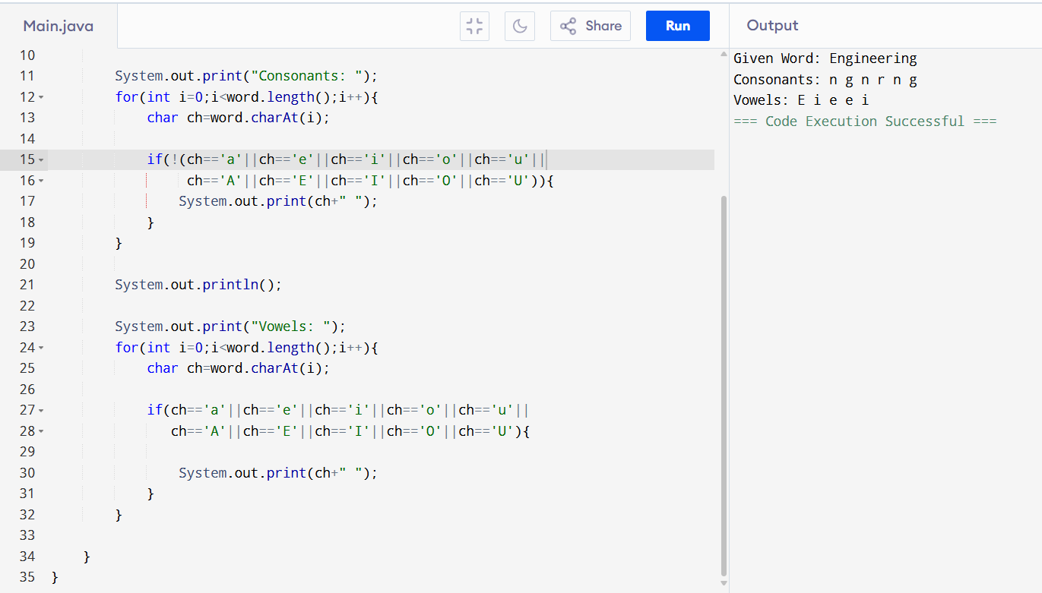

8. Find Character in String and Print Index

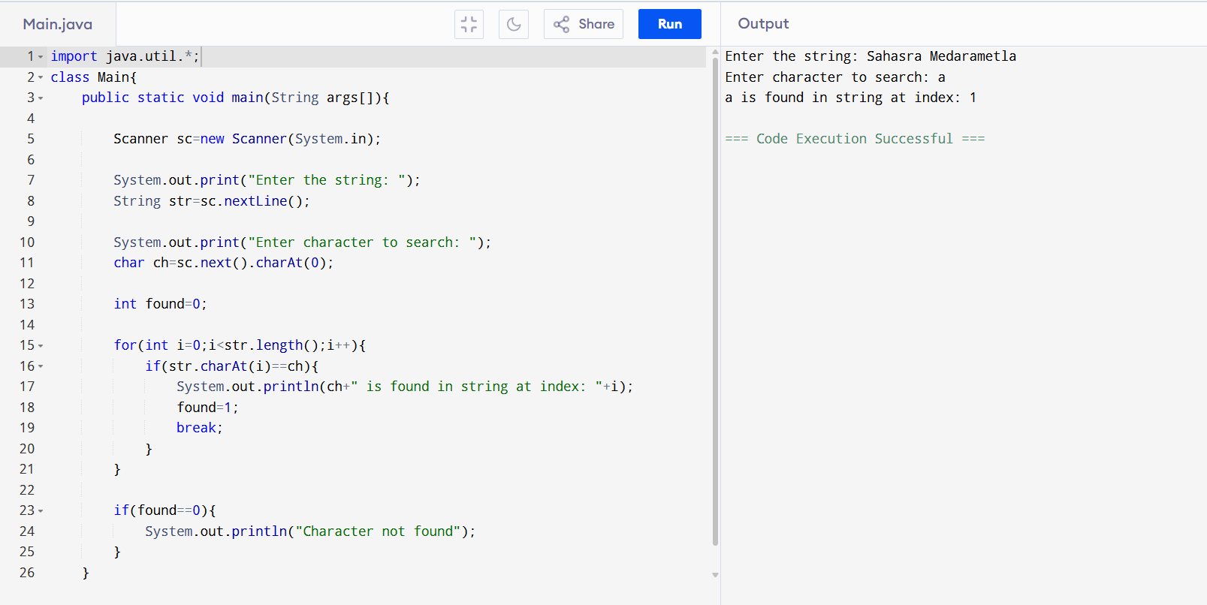

9. Arrange Letters in Reverse Alphabetical Order

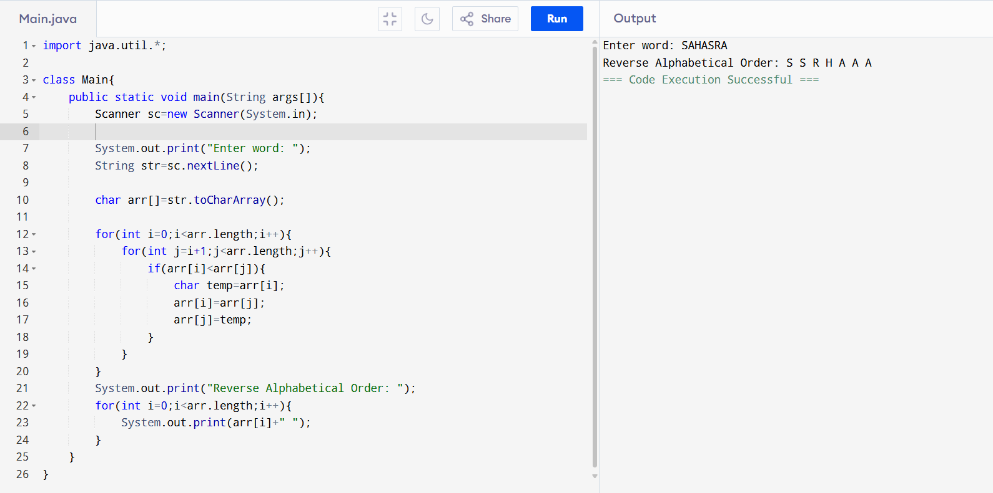

10. Remove Vowels from String

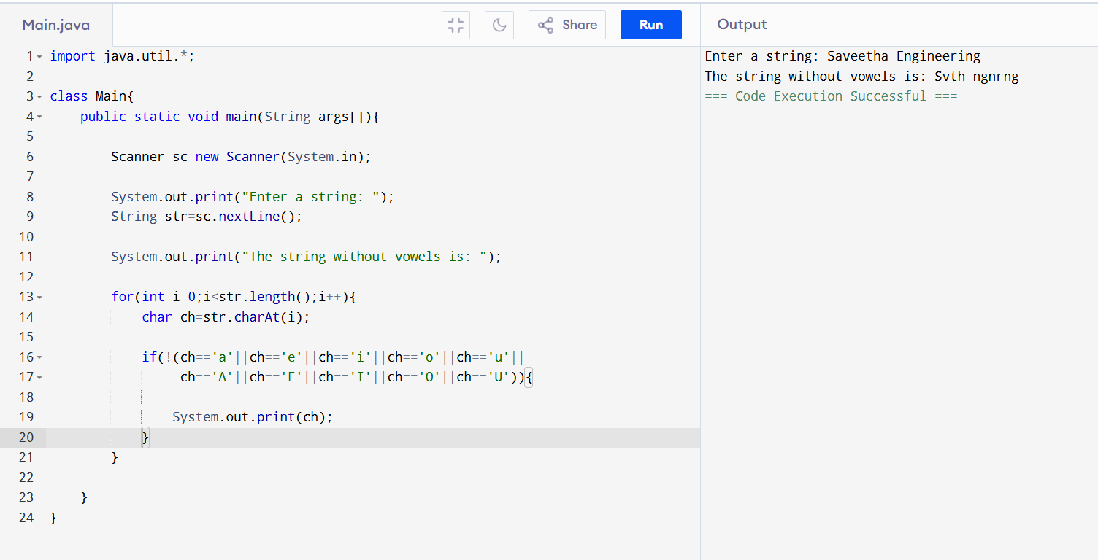

11. Matrix Multiplication

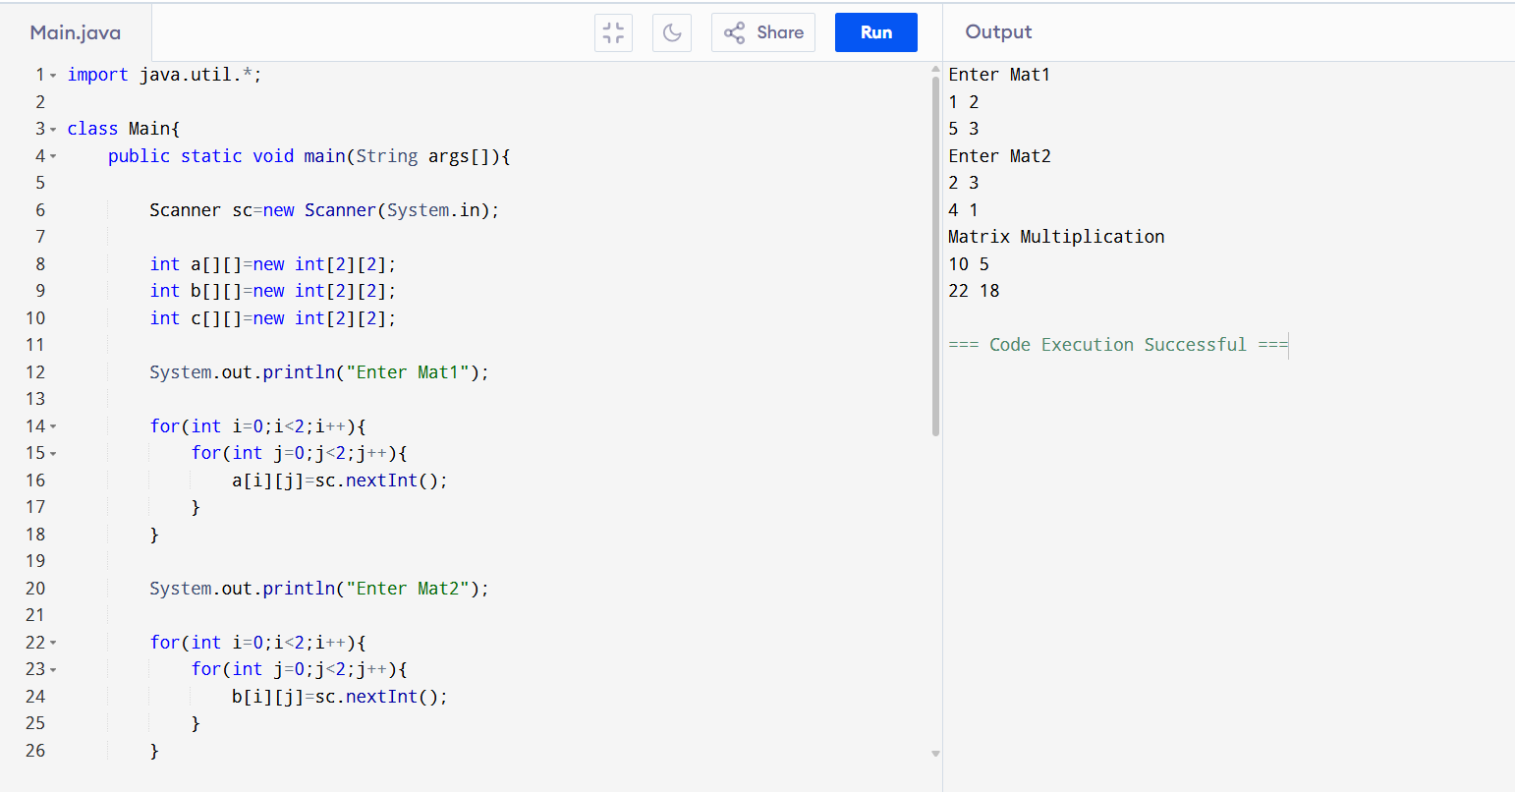

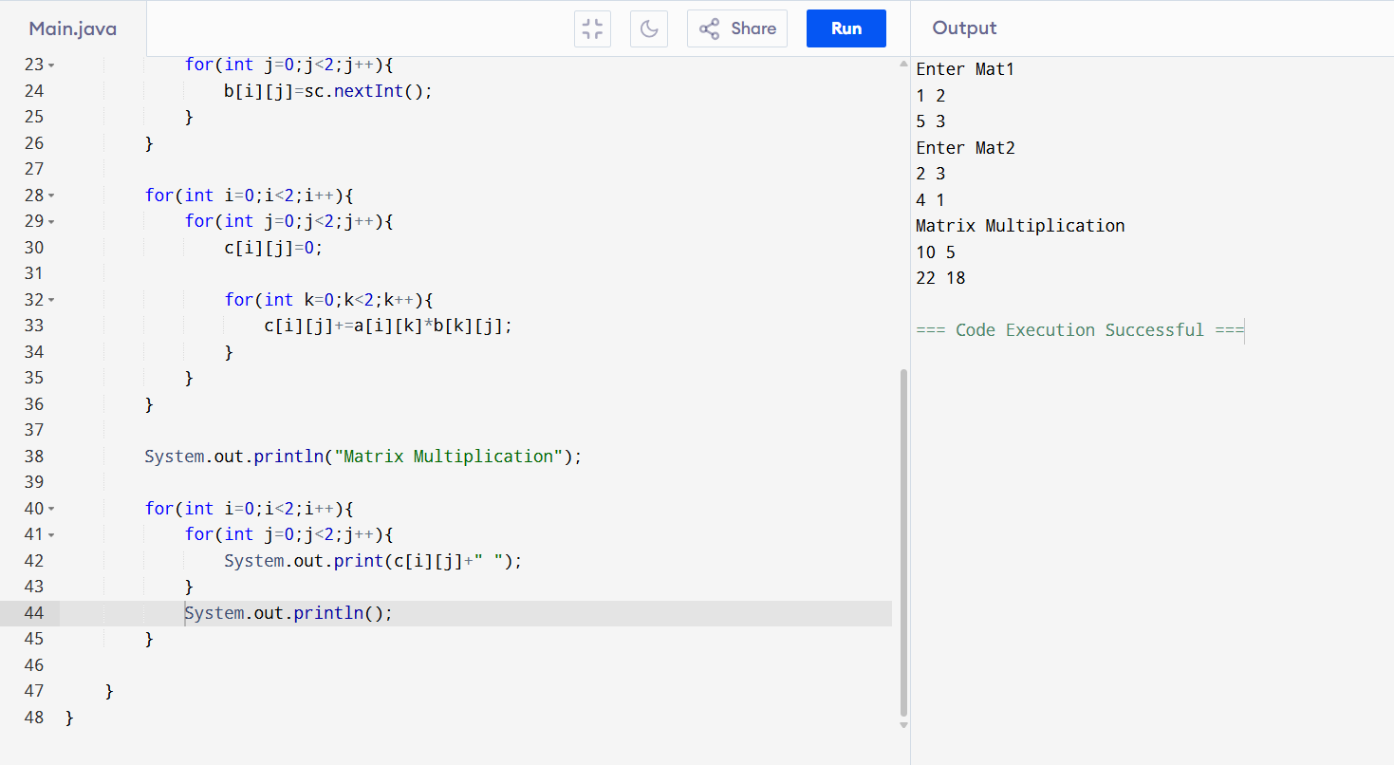

12. Matrix Addition

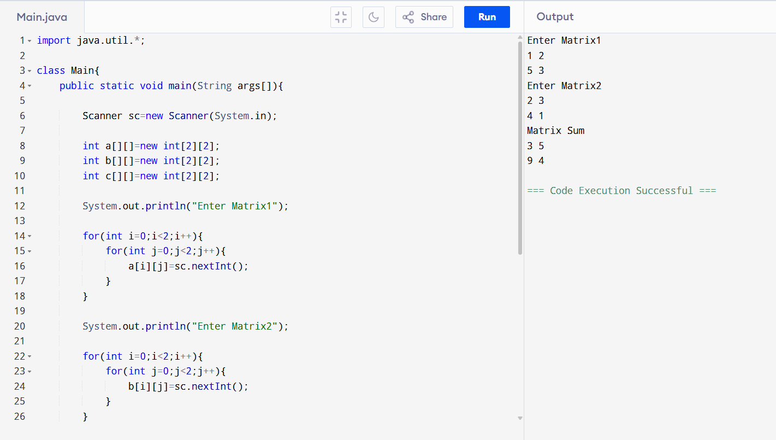

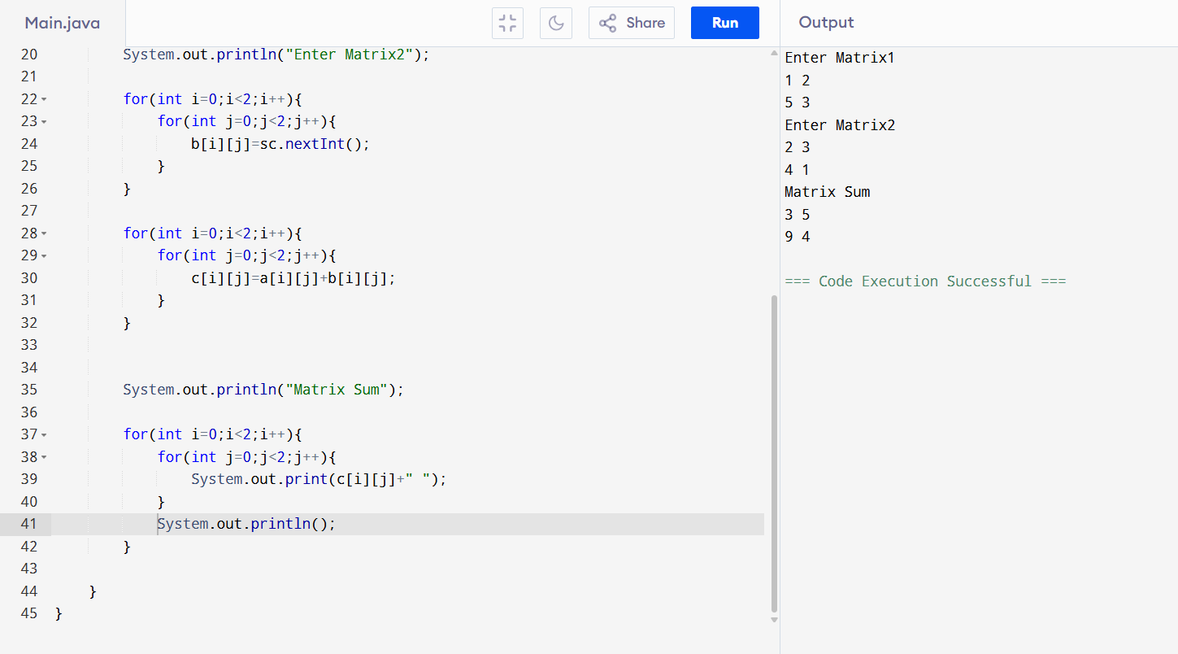

13. Merge Two Sorted Arrays

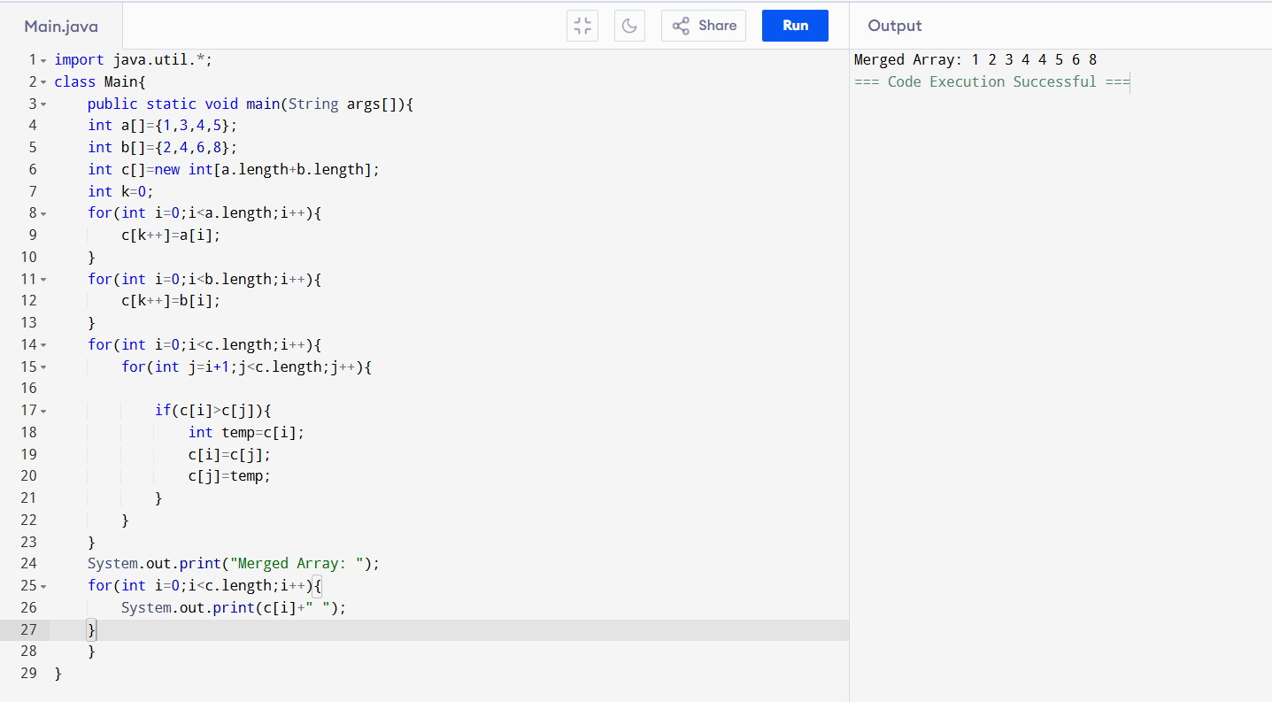

14. Mean Median Mode of Array

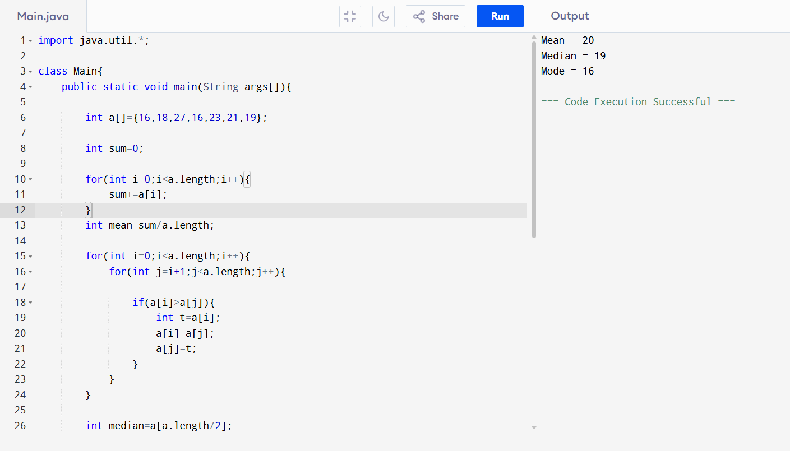
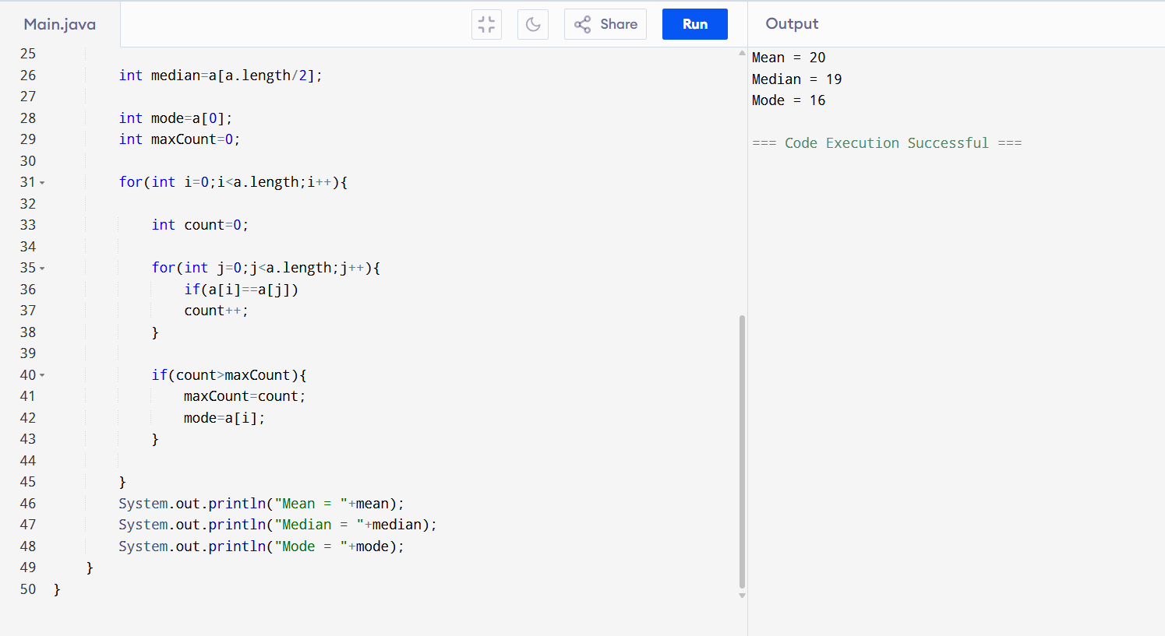

15. Count Composite Numbers in Array

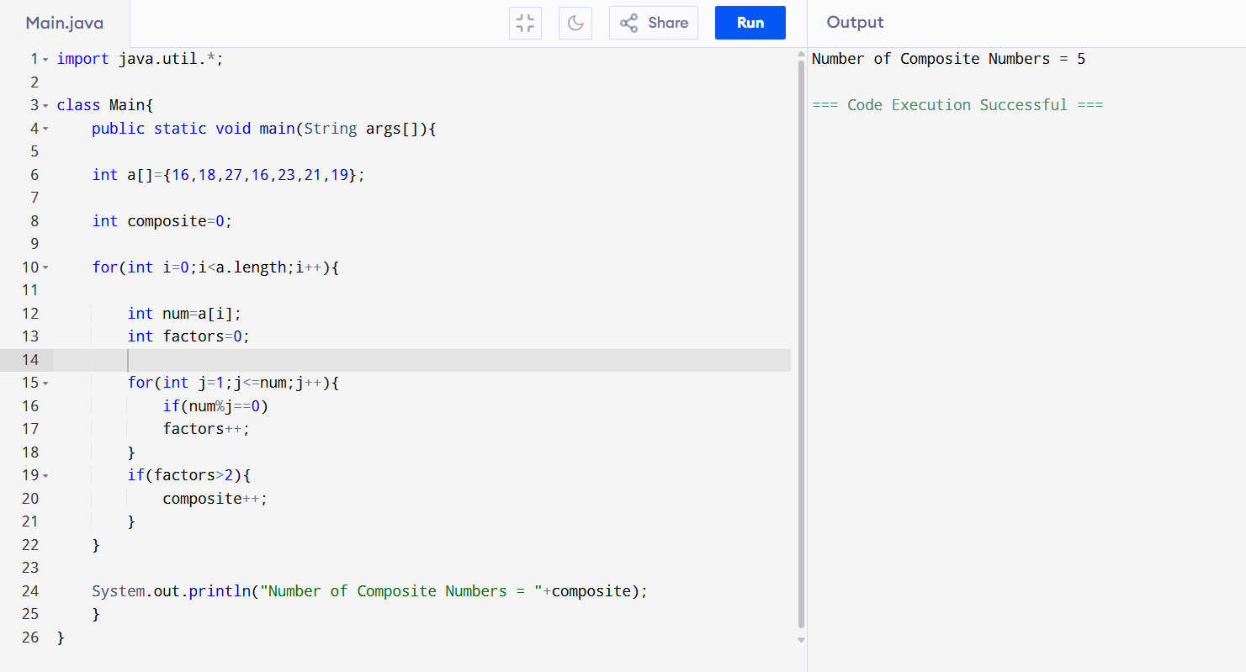

16. Right Triangle Star Pattern

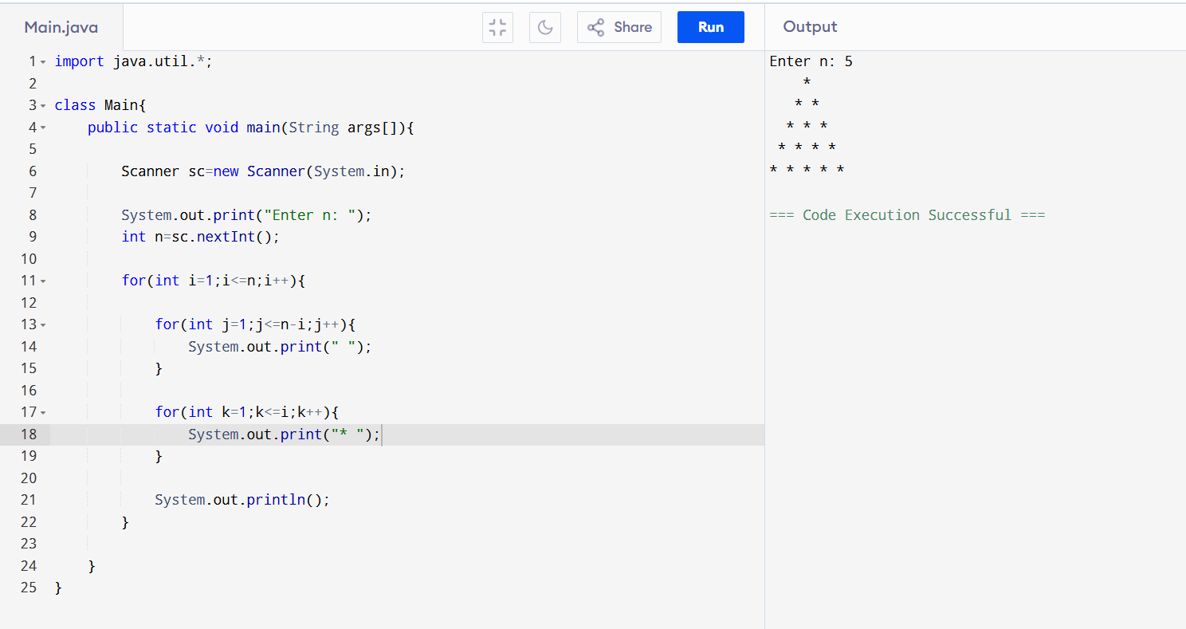

17. Pascal Triangle Pattern

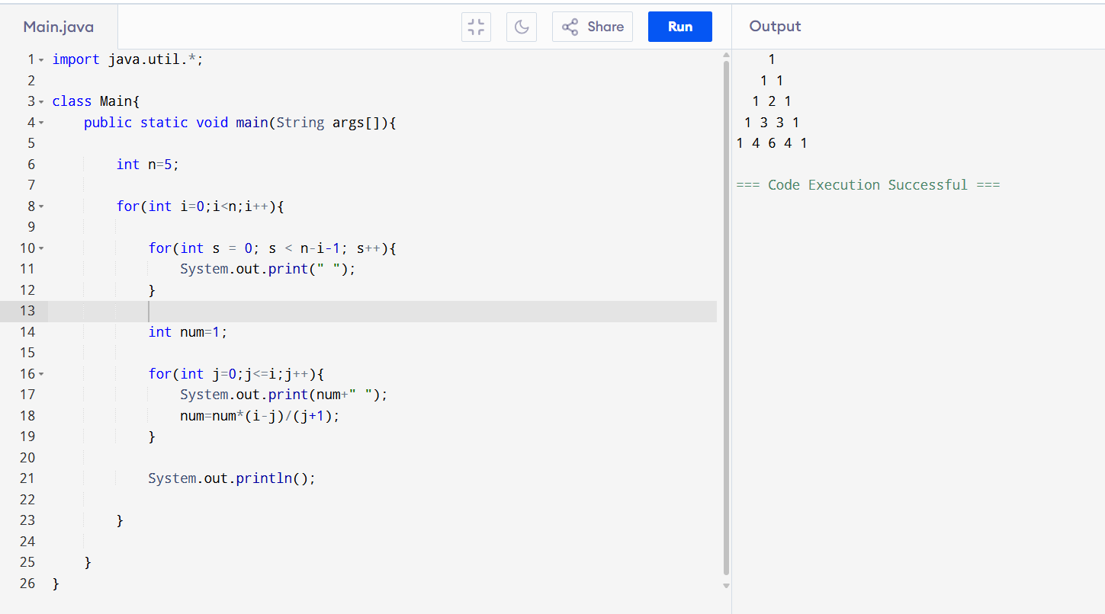

18. Rectangle Symbol Pattern

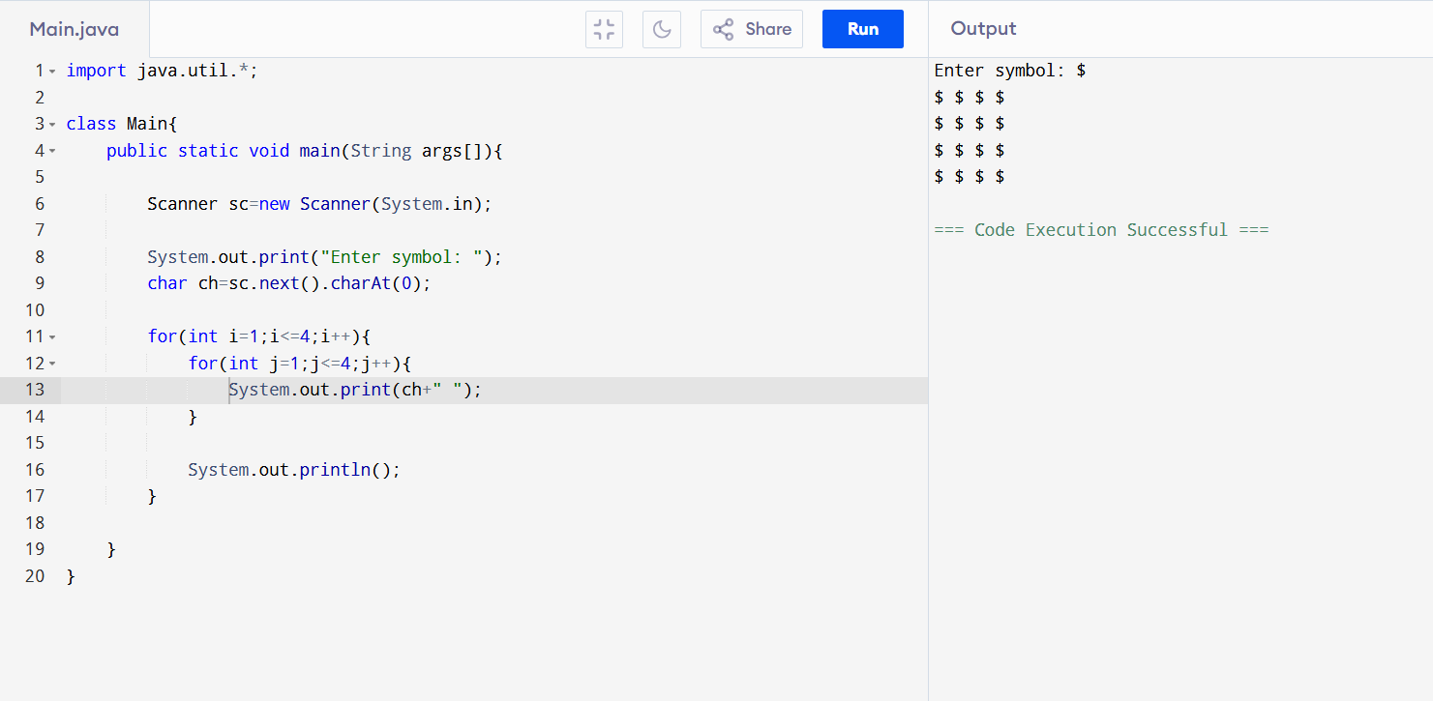

19. Pattern (1 → Pyramid → Reverse)

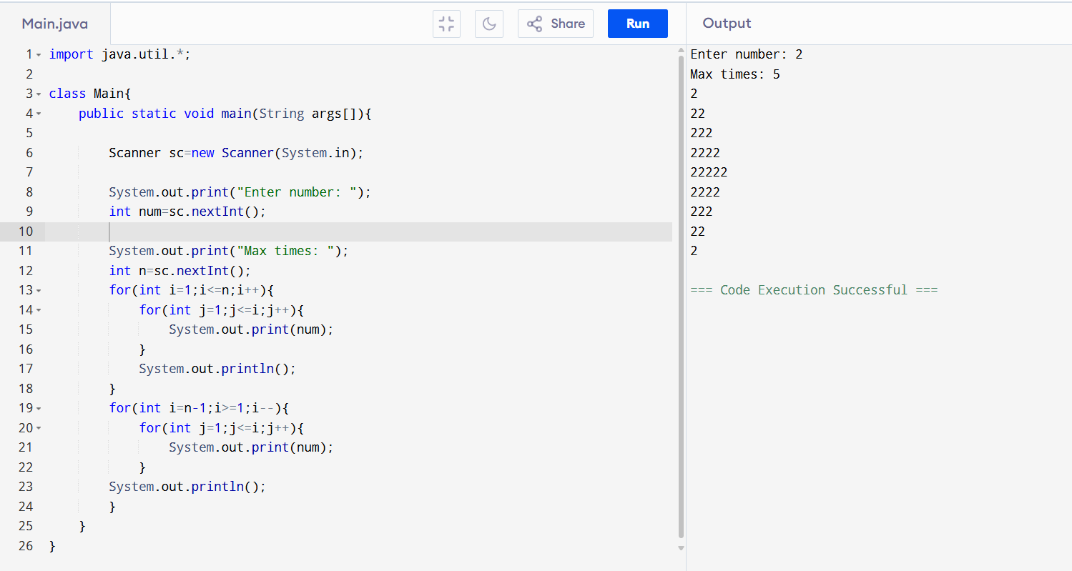

20. Inverted Full Pyramid Pattern

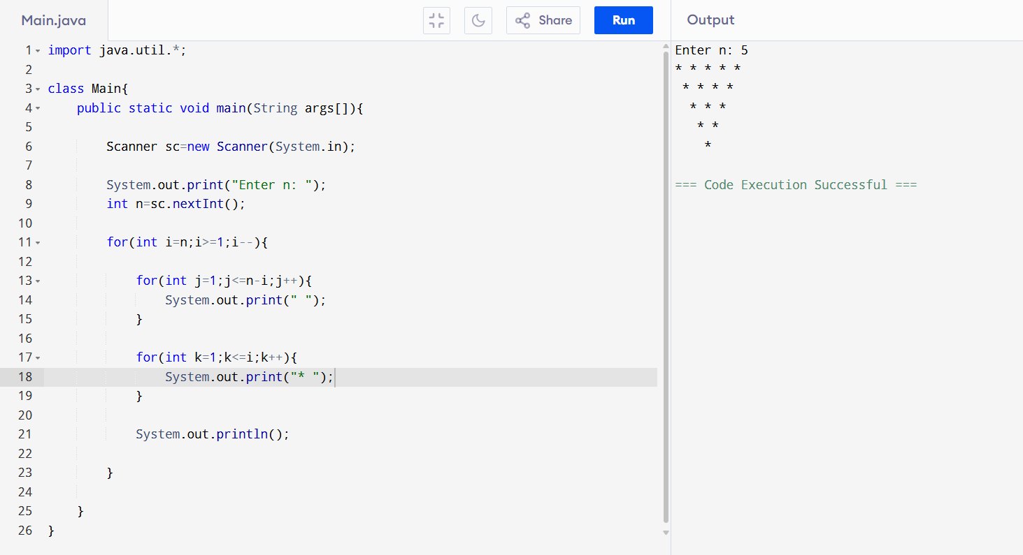

21. Character Triangle Pattern

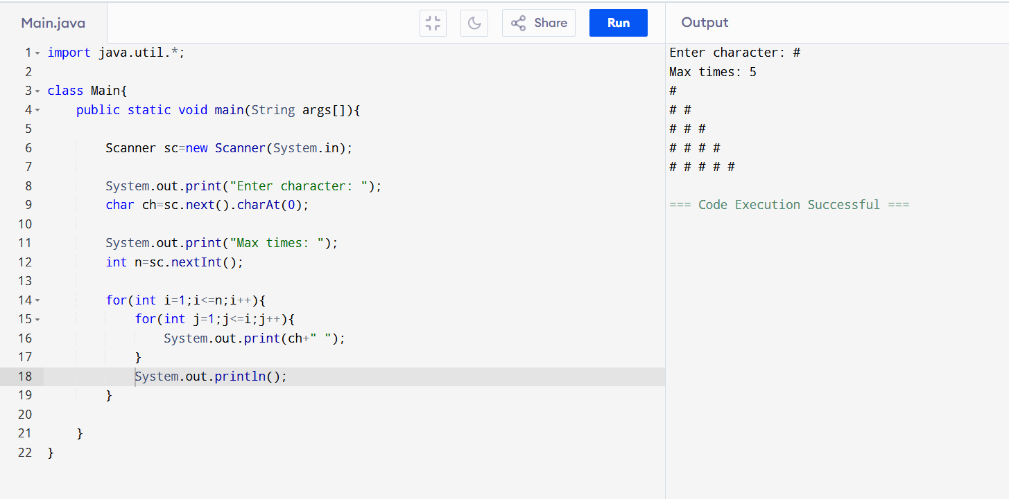

22. Hollow Square Pattern

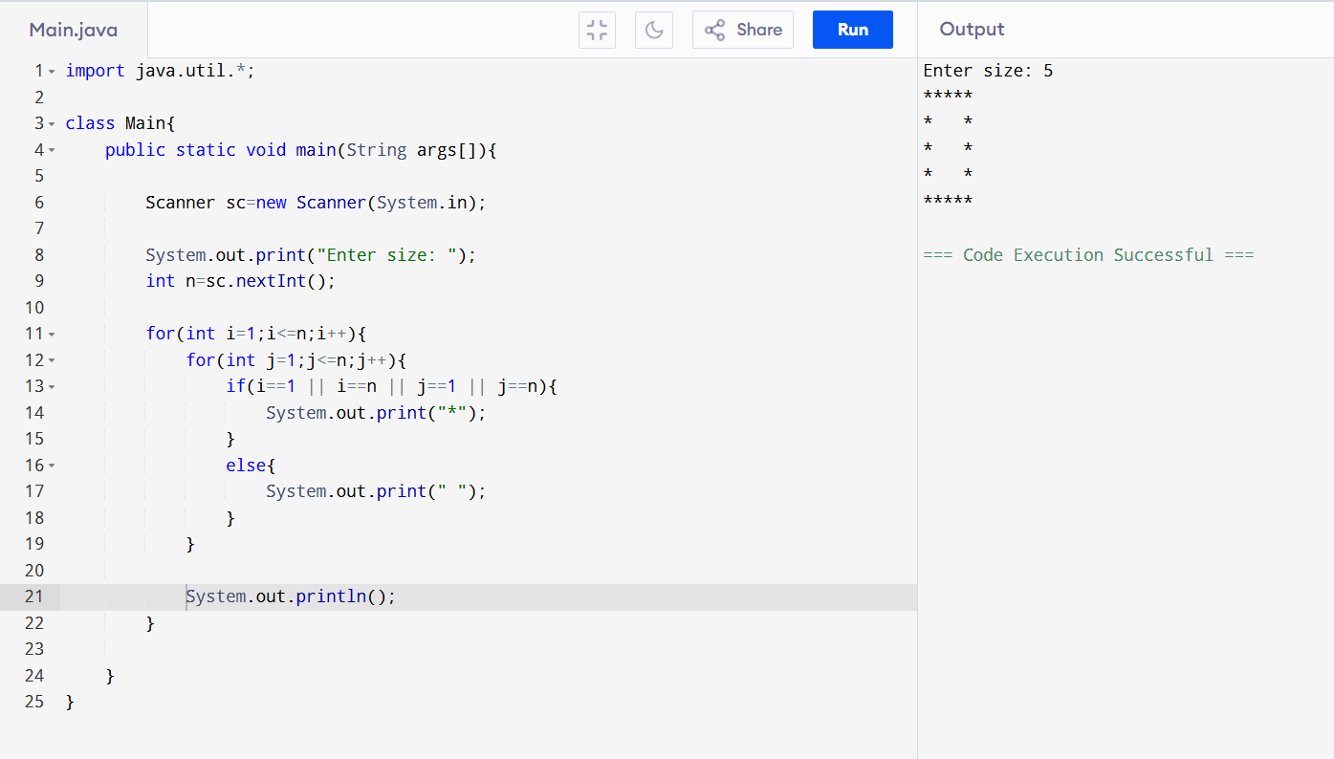

23. Number Triangle Pattern

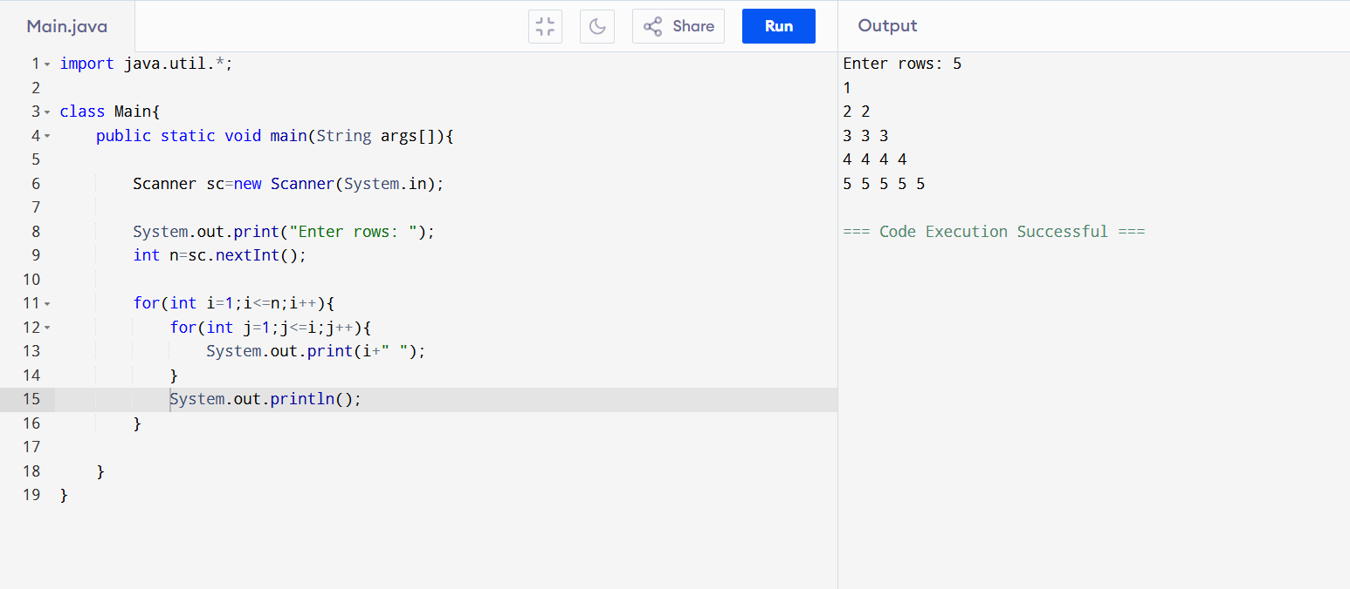

24. Square Numbers Pattern

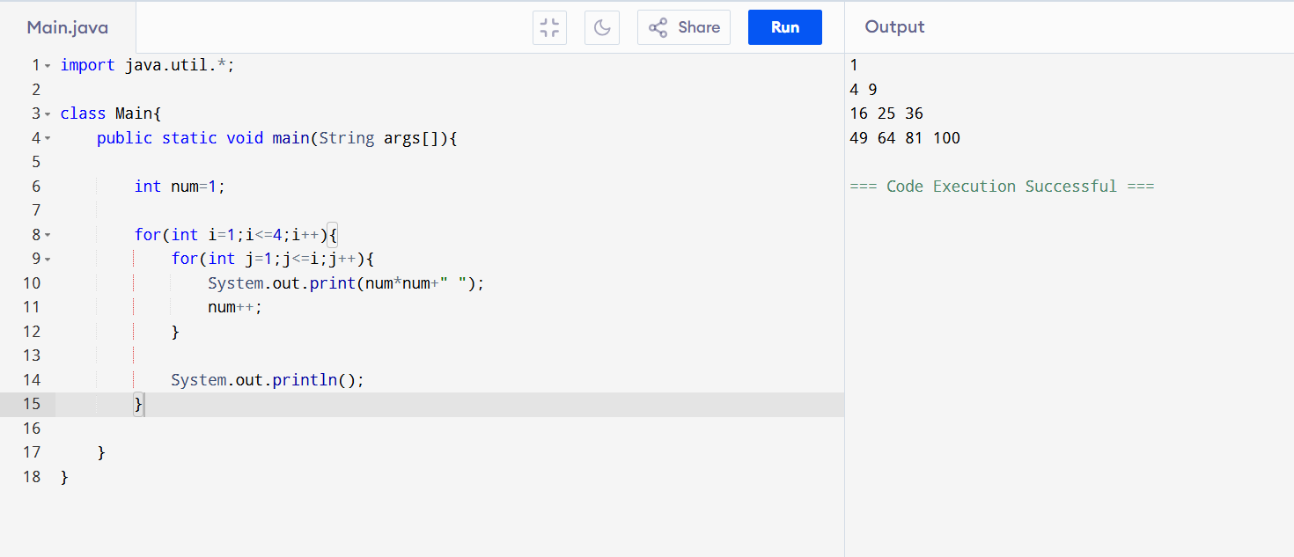

25. Diamond Number Pattern

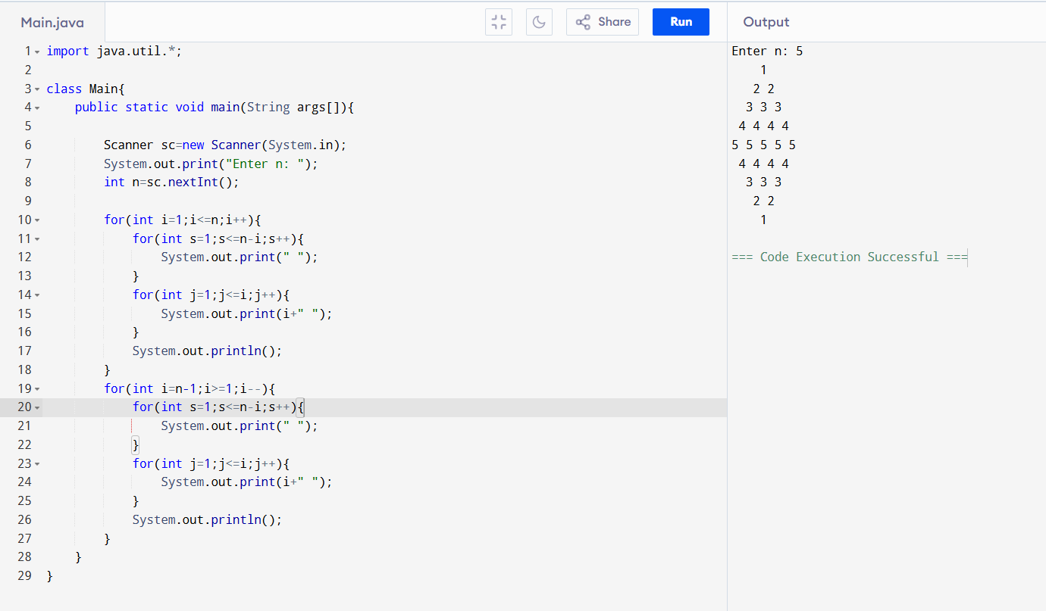

26. Hollow Dollar Square Pattern

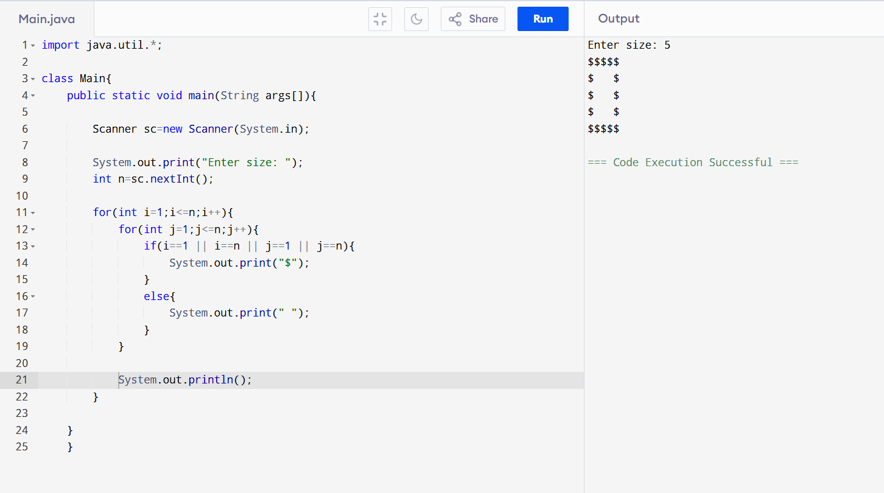

27. Inverted Pyramid Pattern

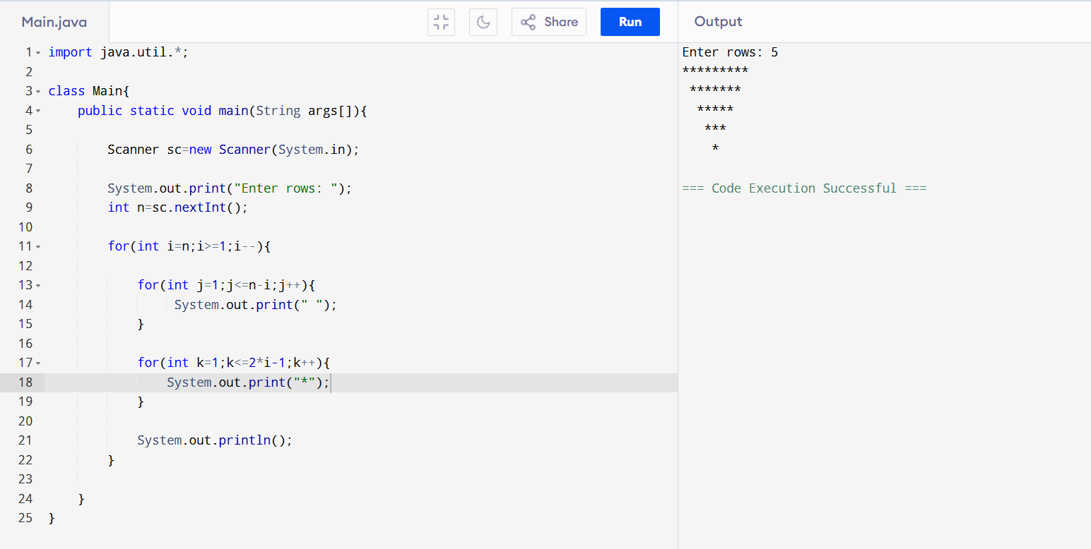

28. Reverse a Number Using Loop

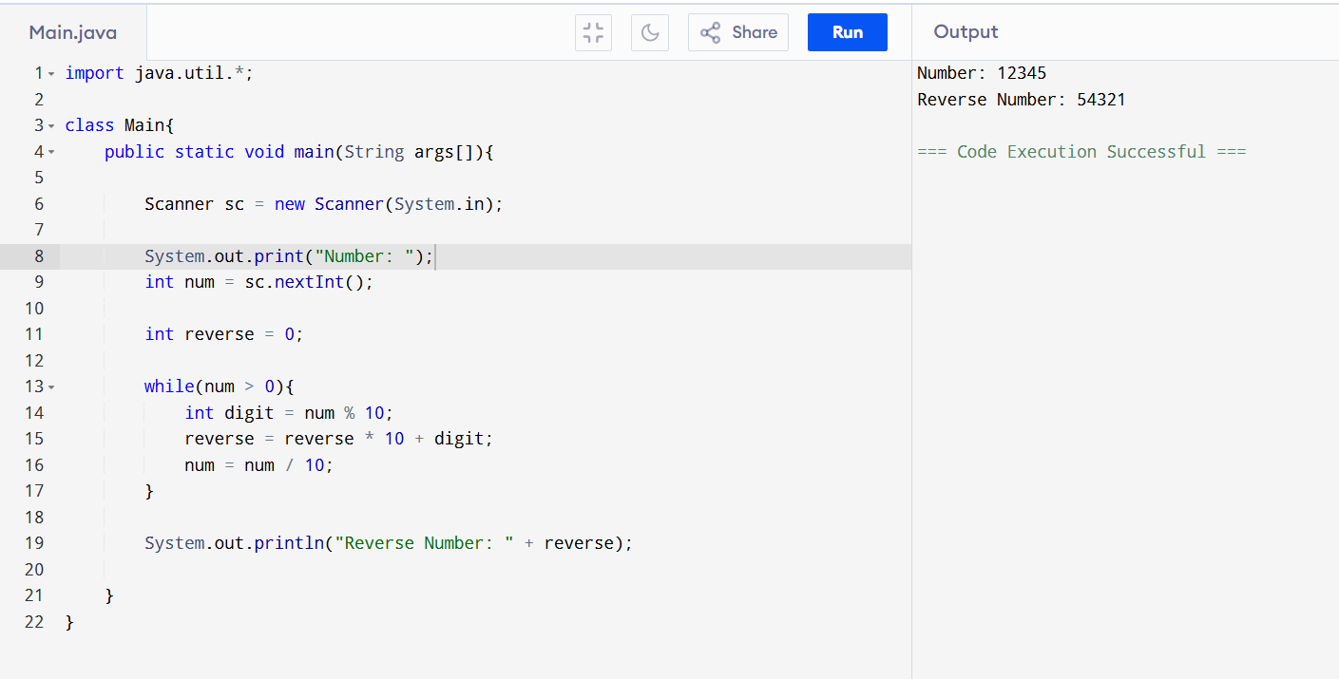

29. Decimal → Binary → Reverse → Decimal

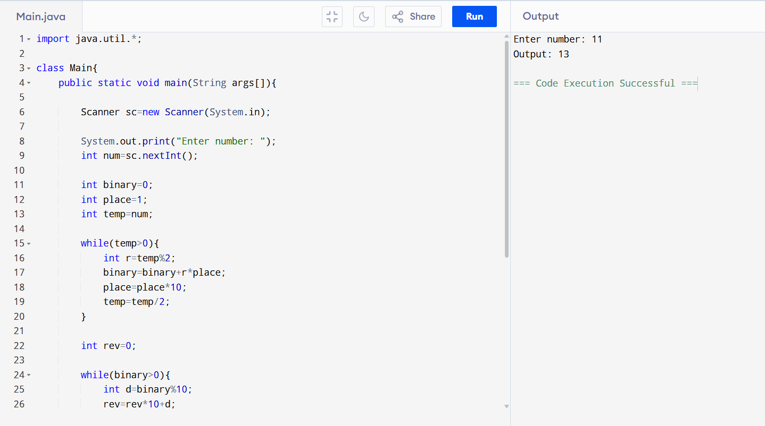
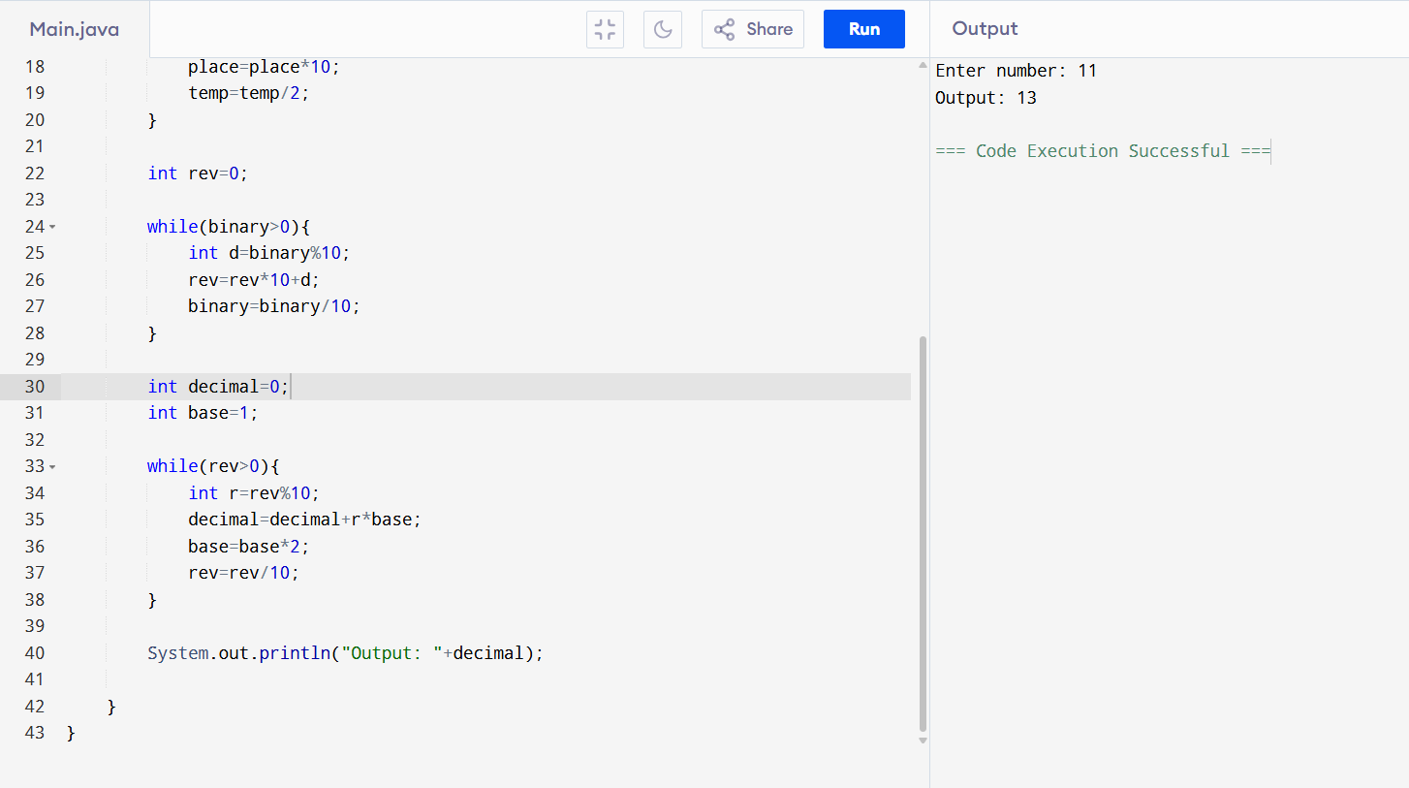

30. Voting Eligibility Program

